
The World Market Study of SCADA, Energy Management, Distribution Management & Outage Management Systems in Electric Utilities: 2013-2015
4 Volume Series
See Order Information on last page for details
This publication is Newton-Evans Research Company’s tenth major in-depth international research program on supervisory control and data acquisition (SCADA) systems, energy management systems (EMS), distribution management systems (DMS), and Outage Management Systems (OMS). The four volume series measures current market size and offers projections on a world region basis through the year 2015. It includes a North American Market Survey and Analysis, International Market Survey and Analysis, World Market Assessment and Forecast, and SCADA/EMS/DMS/OMS Supplier Profiles for major companies.
The world regions included in the research publications are North America, Western Europe, Central/Eastern Europe, Mediterranean, Middle East, Sub-Saharan Africa, Latin America, and Asia Pacific. The series provides a comprehensive and informative report on the control systems usage patterns and plans of electric utilities around the world.
Key Issues Addressed
- Approximate number of Poletop RTUs, Feeder/secondary RTU’s/Smart DA devices, Substation RTUs, PLCs, SA platforms, Synchrophasor measurement units, and Substation level phasor data concentrators. Anticipated numbers planned for installation by year-end 2015, along with protocol requirements.
- Have utilities converged SCADA/DMS and OMS functions?
- Cyber security concerns if EMS/DMS or DMS/OMS are combined.
- Plans to implement IEC 61850 beyond 2015.
- Communications Methods in use and planned for use
Sample Survey Topics
- Extent of use of SCADA, EMS and DMS systems by the world’s electric power utilities.
- How distribution circuit designs move from GIS to DMS
- SCADA/EMS/DMS/OMS procurements. New, replacement and upgrade plans for SCADA/ EMS/DMS.
- External assistance and third party services requirements in control center operations.
- Choice of communications protocols within substation, & from substation to external EMS/SCADA/DMS host network.
- Deployment of Operational Analytics
- Unit responsibility for hardware server maintenance
Research Methods
Chief operations and chief engineering personnel were the principal source of information for this program of the world electric power market for SCADA, EMS, DMS and OMS systems in electric utilities. The field survey work is conducted using several primary research methods including personal interviews, e-mail, mail and fax surveys, with telephone follow-up conducted by Newton-Evans staff and research partners. Discussions and information exchanges with international suppliers provide additional market insight.
Sample Charts:
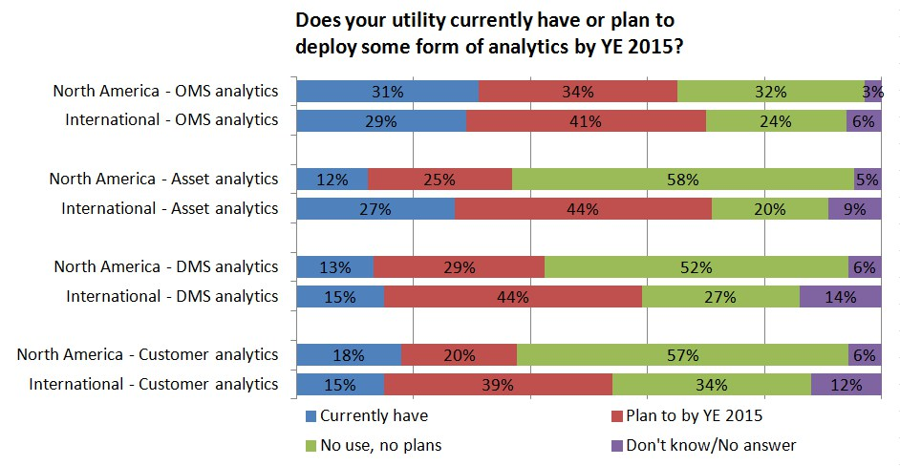
Value Range Value Range
$5,000-$99,999 $100,000 - $499,999
Estimated # of Projects Estimated # of Projects
Low High Low High
2005 250 450 40 70
2006 300 500 40 75
2007 300 500 40 80
2008 350 600 40 90
2009 350 600 40 100

Value Range Value Range
$500,000 - $999,999 $1 MILLION & OVER
Estimated # of Projects Estimated # of Projects
Low High Low High
2005 8 15 7 12
2006 10 20 8 15
2007 10 25 10 20
2008 10 30 12 30
2009 15 35 20 35

Ordering Information:
To order this report series, phone, fax or mail this form with a check (U.S. dollars) or purchase order number to Newton-Evans Research Company, Inc., 10176 Baltimore National Pike, Suite 204, Ellicott City, Maryland 21042, USA. You may also visit our website at www.newton-evans.com to place your order via credit card, and download the reports directly.
Research Series
World Market Study of SCADA, EMS, DMS and OMS Systems in Electric Utilities: 2013-2015
COMPLETE SET → $7,500.00
Volume 1 – North American Market Survey and Analysis $2500
Volume 2 – International Market Survey and Analysis $2500
Volume 3 – World Market Analysis/Forecast $2500
Volume 4 – Supplier Profiles $750

*all reports delivered via email as .PDF documents. Please provide your email address and phone number below.
Name: |  |  |  |  |  |  |  |  |  | Title:
Company: |  |  |  |  |  |  |  |  |  | E-Mail:
Billing Address:
City: |  |  |  |  |  | State: |  |  |  |  |  | Zip/Postal Code:
Country: |  |  |  | Phone: |  |  |  |  |  |  |  | Fax:
Check is enclosed |  |  | Our P.O. # is: |  |  |  |  |  |  |  |  |  |  |  |  | VISA Mastercard  AmEx Discover
Card Number: |  |  |  |  |  |  |  |  |  | Exp. Date: |  |  |  |  |  |  | CVV2 CODE:
Name on Card: |  |  |  |  |  |  |  | Signature:

Or Contact Us:
Phone: 410-465-7316 Toll-Free: 800-222-2856 Fax: 410-750-7429
www.newton-evans.com info@newton-evans.com

